ARTIFICIAL INTELLIGENCE LAB — LAB 5
TASK 1 AND TASK 2 AND TASK 3
Name: Abdul Raheem
Roll Number: 041
This report contains the Minimax implementation for Task 1 and the leaf-evaluation counter comparison for Minimax and Alpha-Beta Pruning for Task 2.

TASK 1: MINIMAX ALGORITHM

Objective
Implement the Minimax algorithm for a binary game tree. MAX chooses the larger child value, while MIN chooses the smaller child value. The values are propagated from the leaf nodes to the root.

Input and Method
The leaf scores are [3, 5, 2, 9, 0, 7]. The code pads the score list with zeros to complete a binary tree of depth 3. Minimax recursively evaluates the tree from the leaves upward.

Program Screenshots
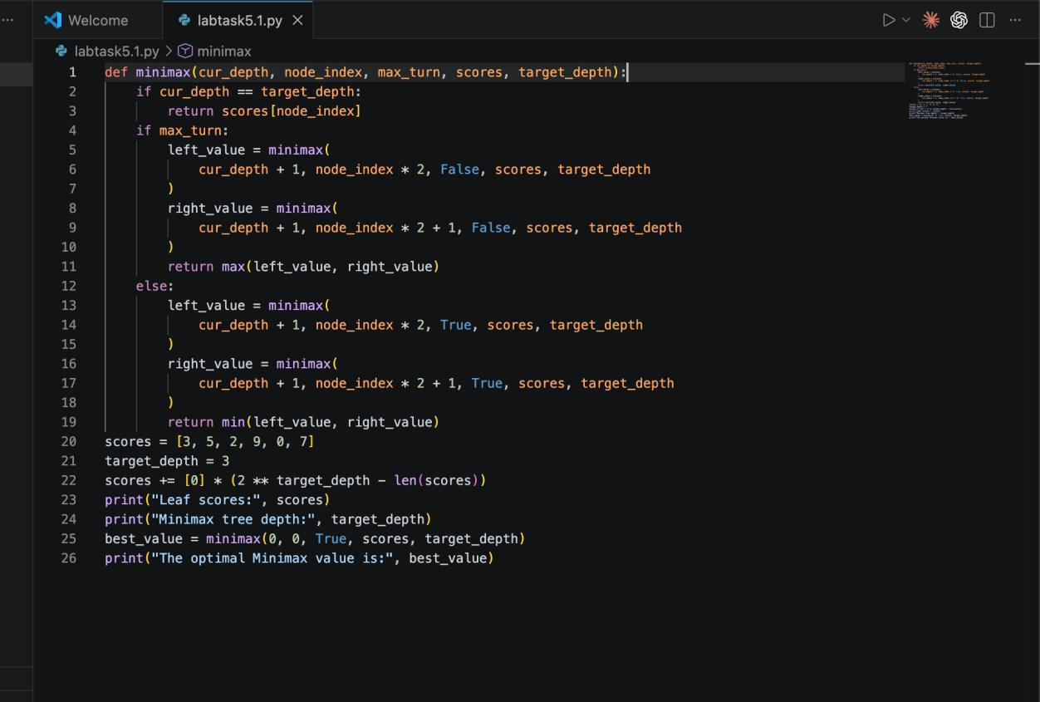
Task 1 output.
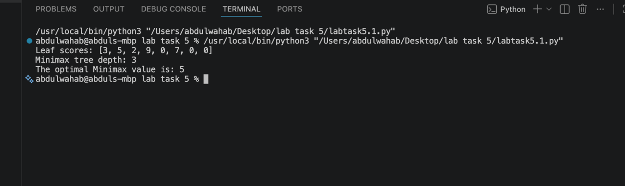

Result and Explanation
The output reports the leaf scores [3, 5, 2, 9, 0, 7, 0, 0], tree depth 3, and an optimal Minimax root value of 5.
Item | Result
Leaf scores used | [3, 5, 2, 9, 0, 7, 0, 0]
Tree depth | 3
Optimal Minimax value | 5

TASK 2: MINIMAX VS. ALPHA-BETA PRUNING

Objective
Count how many leaf nodes are evaluated by Minimax and Alpha-Beta Pruning using the same tree and scores, then compare their root values and evaluation counts.

Method
A counter is incremented whenever the recursion reaches a leaf at the target depth. Alpha-Beta Pruning also maintains alpha and beta bounds and stops exploring a branch when alpha is greater than or equal to beta.

Program Screenshots
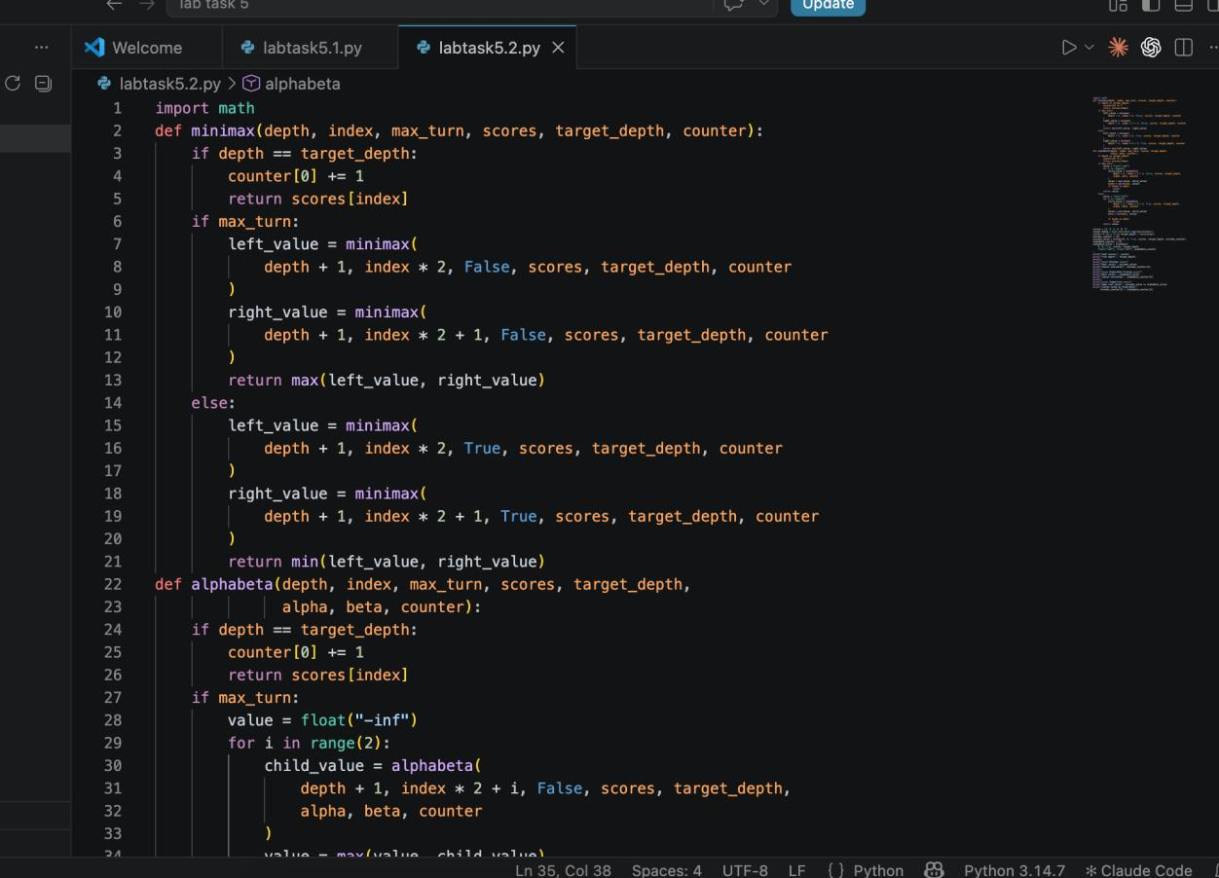
Task 2 output.
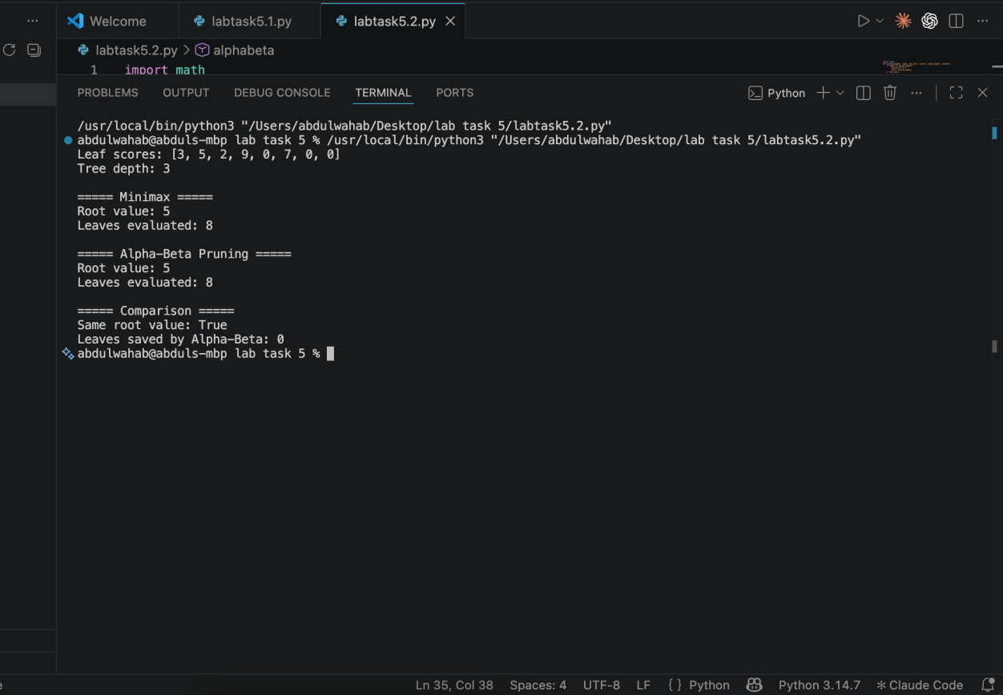

Results and Comparison
Measure | Minimax | Alpha-Beta
Root value | 5 | 5
Leaves evaluated | 8 | 8

In this run, both algorithms return the same root value (5) and evaluate 8 leaves. Alpha-Beta Pruning saves 0 leaf evaluations with this tree and left-to-right child ordering. This is a valid outcome: pruning depends on the values and the order in which branches are visited.

Task 3: Branch Ordering and Pruning Comparison
Task requirement: Reorder the branches and observe the effect on pruning while keeping the Minimax root value unchanged.

Code Screenshot
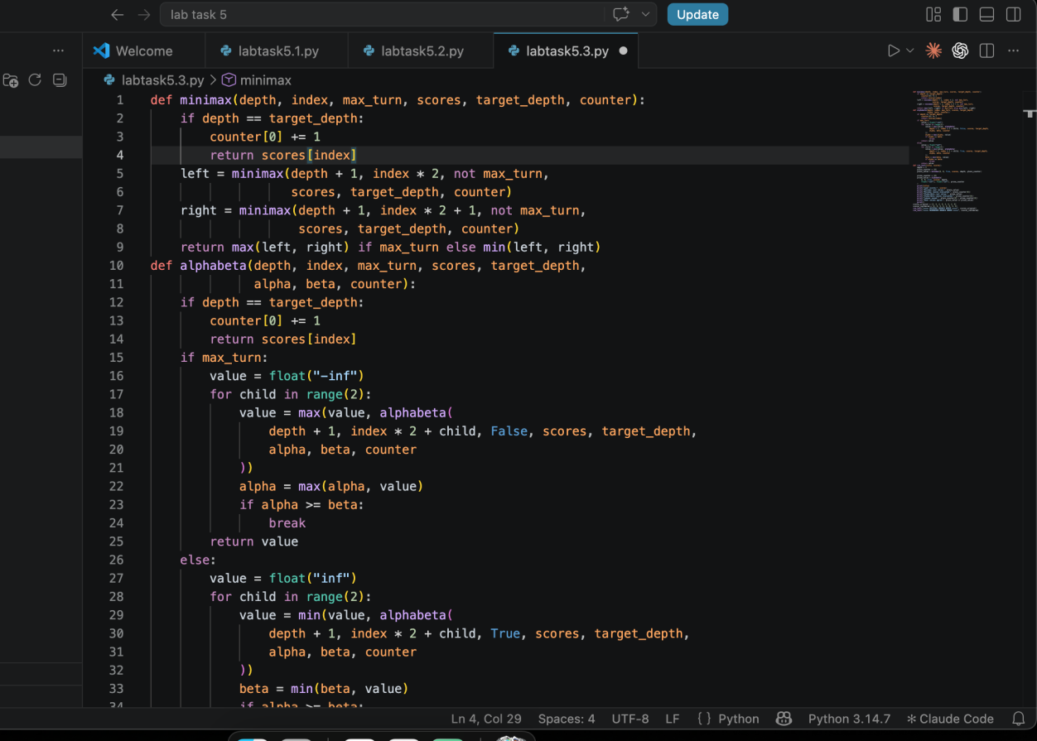

Program Output Screenshot
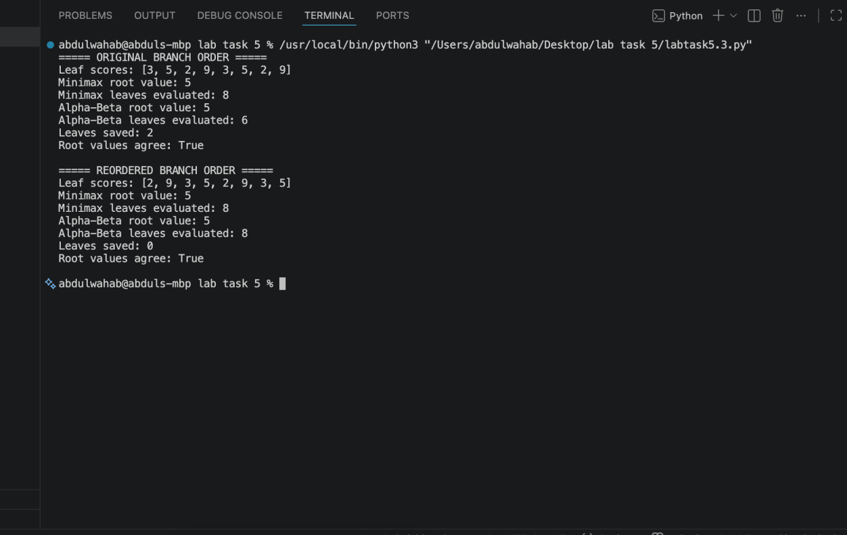

Result
Both branch orders return root value 5. With the original branch order, Alpha-Beta evaluates 6 leaves and saves 2; with the reordered branches, it evaluates all 8 leaves and saves 0. This shows that branch ordering affects pruning efficiency, not the Minimax result.

Conclusion
The experiments show that Minimax and Alpha-Beta Pruning agree on the optimal root value. Alpha-Beta pruning can reduce the number of evaluated leaves, and the amount of reduction depends on the order in which branches are explored.

